Session 2025-2026

Vision: To be a well-known centre for pursuing computer education through innovative pedagogy, value-based education and industry collaboration | Mission: To establish learning ambience for ushering in computer engineering professionals in core and multidisciplinary area by developing Problem-solving skills through emerging technologies.
Program Educational Objectives of the program (PEO): (broad statements that describe the professional and career accomplishments)
PEO1 | Preparation | P: Preparation | Pep-CL abbreviation pronounce as Pep-si-lL easy to recall
PEO2 | Core Competence | E: Environment (Learning Environment)
PEO3 | Breadth | P: Professionalism
PEO4 | Professionalism | C: Core Competence
PEO5 | Learning Environment | L: Breadth (Learning in diverse areas)

Program Outcomes (PO): (statements that describe what a student should be able to do and know by the end of a program)

Keywords of POs:
Engineering knowledge, Problem analysis, Design/development of solutions, Conduct Investigations of Complex Problems, Engineering Tool Usage, The Engineer and The World, Ethics, Individual and Collaborative Team work, Communication, Project Management and Finance, Life-Long Learning
PSO Keywords: Cutting edge technologies, Research

“I am an engineer, and I know how to apply engineering knowledge to investigate, analyse and design solutions to complex problems using tools for entire world following all ethics in a collaborative way with proper management skills throughout my life.” to contribute to the development of cutting-edge technologies and Research.

Integrity: I will adhere to the Laboratory Code of Conduct and ethics in its entirety.

Name and Signature of Student and Date
(Signature and Date in Handwritten)
Disha Angalwar
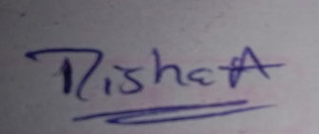

Session | 2025-26 (EVEN) |  | Course Name | JAVA FSD Lab
Semester | 4 |  | Course Code | 23ADS1407
Roll No | 15 |  | Name of Student | Richa Waghmare
Practical Number |  | 03
Course Outcome |  | - Develop backend applications using object-oriented programming concepts and implement data persistence using relational databases.  - Design and implement interactive and responsive user interfaces using standard web technologies.  - Build and integrate complete web applications by combining client-side and server-side components
Aim |  | Write a program to design a simple calculator using control  statement
Problem Definition |  | To write a Java program that designs a simple calculator using control statements. The program should accept two numbers and an arithmetic operator from the user and perform the  corresponding operation using a switch control statement.
Theory  (100 words) |  | A calculator is a simple application that performs arithmetic operations such as addition, subtraction, multiplication, and division. In programming, control statements are essential for decision making in a program. These statements allow the program to execute different blocks of code depending on conditions. One useful control statement is the switch statement, usually used when many conditions depend on a single variable or expression. In Java, the switch statement checks an expression and executes the matching case block. It often improves readability compared to long if else chains. Using a switch statement in a calculator program helps select the correct operation.

Procedure and Execution | Algorithm:  - Start the program.  - Declare variables to store two numbers and an operator.  - Read two numbers from the user.  - Read the operator (+, -, *, /) from the user.  - Use a switch statement to select the operation based on the operator.  - Perform the corresponding arithmetic operation.  - Display the result.  - If the operator is invalid, display an error message.  - Stop the program.
(100 Words)
Code:
mport java.util.Scanner;
public class Calculator {
public static void main(String[] args) {
 | Scanner sc = new Scanner(System.in);
 | // Input first number System.out.println("Enter first number: "); double num1 = sc.nextDouble();
 | // Input second number System.out.println("Enter second number: "); double num2 = sc.nextDouble();
// Input operator
System.out.println("Enter an operator (+, -, *, /): "); char operator = sc.next().charAt(0);
 | double result;
// Switch statement switch (operator) {
case '+':
result = num1 + num2; System.out.println("Result: " + result); break;
case '-':
result = num1 - num2;

 | System.out.println("Result: " + result); break;
case '*':
result = num1 * num2; System.out.println("Result: " + result); break;
case '/':
if (num2 != 0) {
result = num1 / num2; System.out.println("Result: " + result);
} else {
System.out.println("Error: Division by zero is not
allowed.");
}
break;
default:
System.out.println("Invalid operator!");
}
sc.close();
}
}
 | Output:
 | 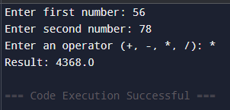
Output Analysis | The program successfully carries out arithmetic operations according to the user’s input. When the user provides valid numbers and a valid operator, the calculator shows the correct output. If the division operation is chosen and the second number is zero, the program avoids division by zero and displays an appropriate error message. If an incorrect operator is entered, the program notifies the user accordingly. This shows that the control statement functions properly and ensures accurate decision making.

Link of student Github profile where  lab assignment has been uploaded | https://github.com/dishaangalwar84/JavaFSD
Conclusion | Therefore, a simple calculator program using control statements was successfully created and implemented. The program illustrates the proper use of the switch statement for decision making and performing arithmetic operations in Java. It is user friendly, simple to understand, and effectively manages different cases. This experiment helps in learning about control structures, handling user input, and understanding basic programming logic.
Plag Report (Similarity index < 12%) | 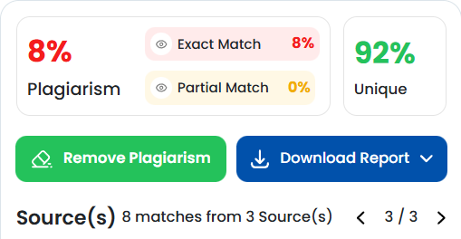
Date | 27 Jan 2025
Faculty signed observation page.

